Manage files with Linux commands

Description
This project involved reorganizing the /home/analyst directory to meet a specified target structure using Linux Bash shell commands. The process included creating and removing directories, moving and deleting files, and editing a text file with the nano editor to document changes. The project simulated a real-world scenario of maintaining a clean, well-structured file system for improved organization and accessibility.
Initial Structure
home
└── analyst
├── notes
│ ├── Q3patches.txt
│ └── tempnotes.txt
├── reports
│ ├── Q1patches.txt
│ └── Q2patches.txt
└── temp

Final Structure
home
└── analyst
├── logs
├── notes
│ └── tasks.txt
└── reports
├── Q1patches.txt
├── Q2patches.txt
└── Q3patches.txt

Task

1. Create the logs directory
Use the mkdir command to make a new folder named logs inside /home/analyst. This folder will serve as the designated location for storing all future log files, ensuring better organization.

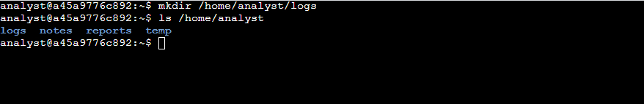

2. Remove the temp directory
Use the rmdir command to delete the unused temp folder from /home/analyst. Removing this folder helps keep the workspace clean and prevents confusion with unnecessary directories.

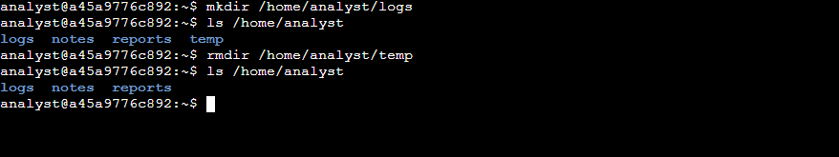

3. Move Q3patches.txt to reports
Navigate to the notes folder and use the mv command to move the Q3patches.txt file into the reports folder. This ensures all quarterly report files (Q1, Q2, and Q3) are stored together in one directory.

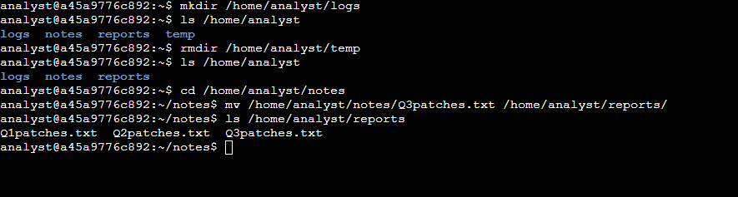

4. Delete tempnotes.txt
Use the rm command to permanently remove the tempnotes.txt file from the notes folder. Deleting outdated or irrelevant files keeps the directory organized and free from clutter.

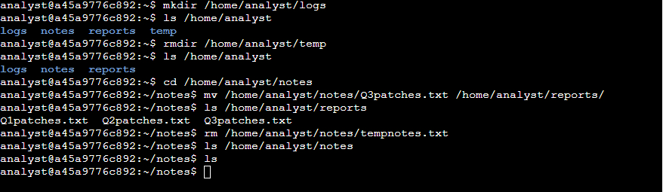

5. Create tasks.txt
Use the touch command to create a new empty file named tasks.txt inside the notes folder. This file will be used as a record to document all changes made during this project.

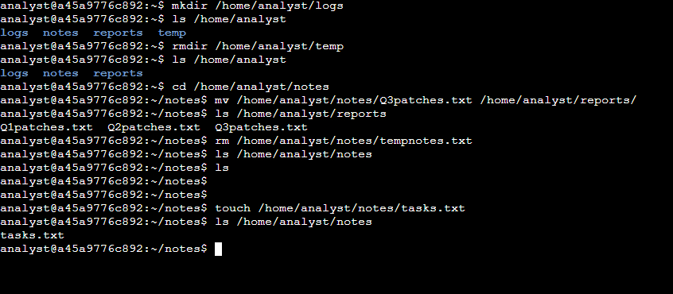

6. Edit tasks.txt in nano
Open the tasks.txt file using the nano text editor. Add a note detailing the tasks you performed, such as creating and removing directories, moving and deleting files, and editing documents. Save and exit nano when done.

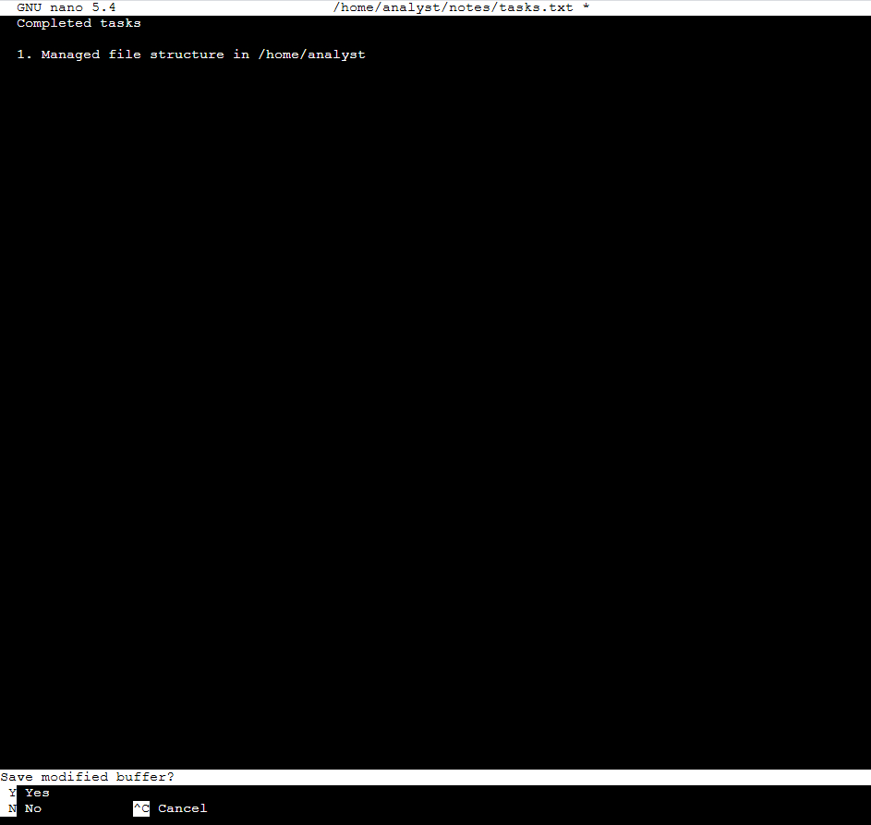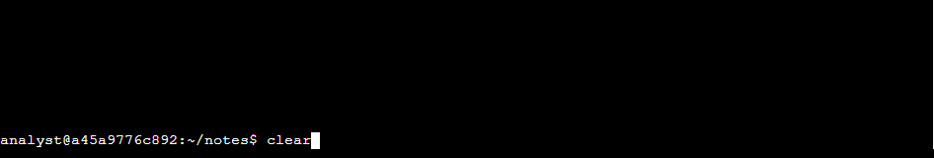

7. Verify the file contents
Use the cat command to display the contents of tasks.txt in the terminal. This confirms that your notes were saved correctly and the file accurately reflects the updates made.

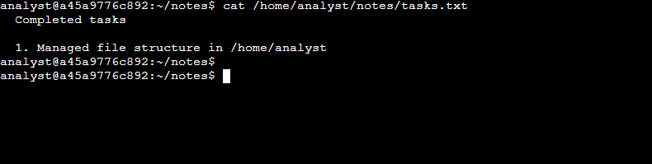

Tasks Completed
- Created a new directory—added a logs subdirectory in /home/analyst to store future log files.
- Removed an unused directory—deleted the temp subdirectory to streamline the workspace.
- Moved a file—Transferred Q3patches.txt from the notes directory to reports to consolidate quarterly reports.
- Removed an outdated file—deleted tempnotes.txt from notes to eliminate unnecessary files.
- Created a documentation file—generated tasks.txt in notes for recording completed tasks.
- Edited a file using nano—added a note in tasks.txt describing all actions performed.
- Verified changes—Used cat to confirm that tasks.txt contained the correct updates.

Skills Demonstrated
- Linux command-line navigation
- File and directory management (mkdir, rmdir, mv, rm)
- File editing using nano
- Change verification with ls and cat

Glossary
mkdir logs
- mkdir—Creates a new directory.
- logs—The name of the new directory to create.
ls /home/analyst
- ls—Lists the contents of a directory.
- /home/analyst– The directory to display.
rmdir temp
- rmdir—Removes an empty directory.
- temp – The name of the directory to remove.
mv Q3patches.txt /home/analyst/reports/
- mv—Moves or renames files and directories.
- Q3patches.txt—The file to move.
- /home/analyst/reports/ – The target directory where the file will be moved.
rm tempnotes.txt
- rm – Removes (deletes) files.
- tempnotes.txt—The file to remove.
touch tasks.txt
- touch—Creates a new empty file or updates the timestamp of an existing file.
- tasks.txt—The file to create.
nano tasks.txt
- nano – Opens the nano text editor.
- tasks.txt—The file to edit.
clear
- clear—Clears the terminal screen.
cat tasks.txt
- cat—Displays the contents of a file.
tasks.txt—The file to display.

